|  |  |
| --- | --- |
| **Student Name** | SASIDHARAN S |
| **Student Roll Number** | 190701193 |

# Data Visualization and Pre-processing

In [44]: 1. Download the dataset

Dataset successfully downloaded and uploaded in colob

# LoadData

df**.**head()

df**=**pd**.**read_csv("Churn_Modelling.csv")

**import** pandas **as** pd

**import** warnings warnings**.**filterwarnings('ignore')

In[25]:

In[26]:

Out[26]:

In[27]:

**RowNumberCustomerId Surname CreditScore Geography Gender Age Tenure Balance NumOfProductsHasCrCardIsActiveMember Estimated Salary Exited**

|  |  |  |  |  |  |  |  |  |  |  |  |  |
| --- | --- | --- | --- | --- | --- | --- | --- | --- | --- | --- | --- | --- |
| **0** | 1 | 15634602 | Hargrave | 619 | France Female | 42 | 2 0.00 | 1 | 1 | 1 | 101348.88 | 1 |
| **1** | 2 | 15647311 | Hill | 608 | Spain Female | 41 | 1 83807.86 | 1 | 0 | 1 | 112542.58 | 0 |
| **2** | 3 | 15619304 | Onio | 502 | France Female | 42 | 8 159660.80 | 3 | 1 | 0 | 113931.57 | 1 |
| **3** | 4 | 15701354 | Boni | 699 | France Female | 39 | 1 0.00 | 2 | 0 | 0 | 93826.63 | 0 |
| **4** | 5 | 15737888 | Mitchell | 850 | Spain Female | 43 | 2 125510.82 | 1 | 1 | 1 | 79084.10 | 0 |

# Perform BelowVisualizations.

* UnivariateAnalysis●Bi-VariateAnalysis●Multi-VariateAnalysis

**import** matplotlib.pyplot**as** plt

**import** seaborn **as** sns

* UnivariateAnalysis

In [28]:

df**.**hist(column**=**"Age",grid**=False**,edgecolor**=**'black')

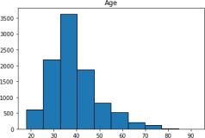Out[28]: array([[<AxesSubplot:title={'center':'Age'}>]], dtype=object)

* + Bi - VariateAnalysis

In [29]:

sns**.**countplot(x**=**'Gender',data**=**df)

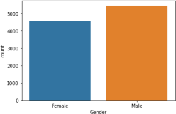Out[29]: <AxesSubplot:xlabel='Gender', ylabel='count'>

* + Multi - VariateAnalysis

In [30]:

sns**.**countplot(x**=**"Tenure",data**=**df)

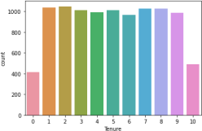Out[30]: <AxesSubplot:xlabel='Tenure', ylabel='count'>

In [32]:

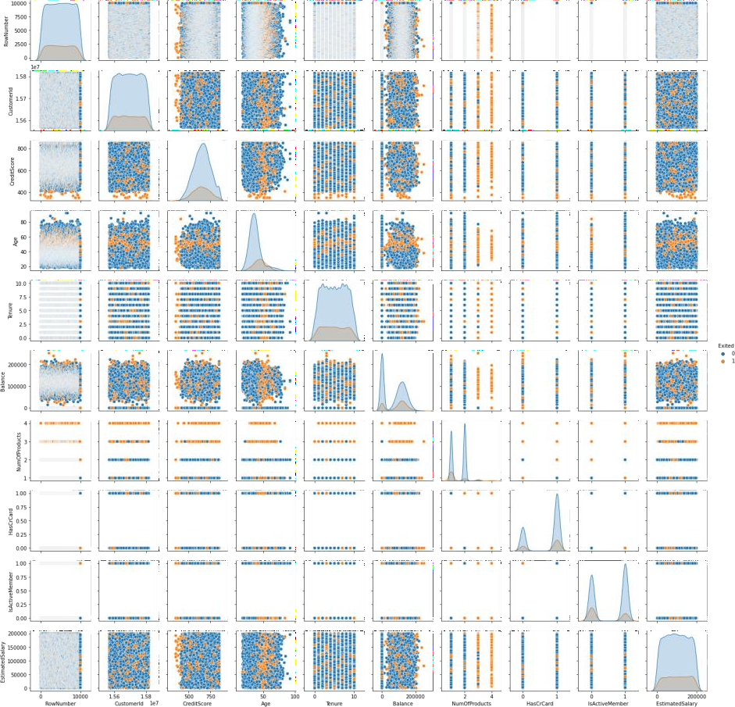Out[32]: <seaborn.axisgrid.PairGrid at 0x180769e67f0>

sns**.**pairplot(df, hue**=**'Exited', height**=**2)

# Perform descriptive statistics on thedataset

In [33]: df**.**describe()

Out[33]:

**RowNumberCustomerIdCreditScore Age Tenure Balance NumOfProductsHasCrCardIsActiveMemberEstimatedSalary Exited count** 10000.00000 1.000000e+04 10000.000000 10000.000000 10000.000000 10000.000000 10000.000000 10000.00000 10000.00000010000.0000 00 10000.000000

|  |  |  |  |  |  |  |  |  |  |
| --- | --- | --- | --- | --- | --- | --- | --- | --- | --- |
| **mean** | 5000.50000 1.569094e+07 | 650.528800 | 38.921800 | 5.012800 76485.889288 | 1.530200 | 0.70550 | 0.515100 | 100090.239881 | 0.203700 |
| **std** | 2886.89568 7.193619e+04 | 96.653299 | 10.487806 | 2.892174 62397.405202 | 0.581654 | 0.45584 | 0.499797 | 57510.492818 | 0.402769 |
| **min** | 1.00000 1.556570e+07 | 350.000000 | 18.000000 | 0.000000 0.000000 | 1.000000 | 0.00000 | 0.000000 | 11.580000 | 0.000000 |
| **25%** | 2500.75000 1.562853e+07 | 584.000000 | 32.000000 | 3.000000 0.000000 | 1.000000 | 0.00000 | 0.000000 | 51002.110000 | 0.000000 |
| **50%** | 5000.50000 1.569074e+07 | 652.000000 | 37.000000 | 5.000000 97198.540000 | 1.000000 | 1.00000 | 1.000000 | 100193.915000 | 0.000000 |
| **75%** | 7500.25000 1.575323e+07 | 718.000000 | 44.000000 | 7.000000 127644.240000 | 2.000000 | 1.00000 | 1.000000 | 149388.247500 | 0.000000 |
| **max** | 10000.00000 1.581569e+07 | 850.000000 | 92.000000 | 10.000000 250898.090000 | 4.000000 | 1.00000 | 1.000000 | 199992.480000 | 1.000000 |

# Handle the Missingvalues

In [34]: df**.**isnull()**.**sum()

Out[34]:RowNumber 0

CustomerId 0

Surname 0

CreditScore 0

Geography 0

Gender 0

Age 0

Tenure 0

Balance 0

NumOfProducts 0

HasCrCard 0

IsActiveMember 0

EstimatedSalary 0

Exited 0

dtype: int64

# Find the outliers and replace theoutliers

In [35]: sns**.**boxplot(x**=**'CreditScore', data**=**df)

Out[35]: <AxesSubplot:xlabel='CreditScore'>

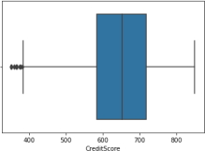

In [45]:

**import** numpy**as** np

**import** sklearn

**from** sklearn.datasets**import** load_boston

Q1 **=** np**.**percentile(df['CreditScore'], 25, interpolation **=** 'midpoint') Q3 **=** np**.**percentile(df['CreditScore'], 75, interpolation **=** 'midpoint')

IQR **=** Q3 **-** Q1

print("Old Shape: ", df**.**shape)

upper**=**np**.**where(df['CreditScore']**>=**(Q3**+**1.5**\***IQR)) lower**=**np**.**where(df['CreditScore']**<=**(Q1**-**1.5**\***IQR)) df**.**drop(upper[0], inplace**= True**) df**.**drop(lower[0], inplace**=True**)

print("New Shape: ", df**.**shape) sns**.**boxplot(x**=**'CreditScore', data**=**df)

Old Shape: (9984,14)

New Shape: (9984,14)

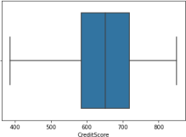Out[45]: <AxesSubplot:xlabel='CreditScore'>

# Check for Categorical columns and performencoding

In [38]: df**.**head()

Out[38]:

**RowNumberCustomerId Surname CreditScore Geography Gender Age Tenure Balance NumOfProductsHasCrCardIsActiveMemberEstimatedSalary Exited**

|  |  |  |  |  |  |  |  |  |  |  |  |  |
| --- | --- | --- | --- | --- | --- | --- | --- | --- | --- | --- | --- | --- |
| **0** | 1 | 15634602 | Hargrave | 619 | France Female | 42 | 2 0.00 | 1 | 1 | 1 | 101348.88 | 1 |
| **1** | 2 | 15647311 | Hill | 608 | Spain Female | 41 | 1 83807.86 | 1 | 0 | 1 | 112542.58 | 0 |
| **2** | 3 | 15619304 | Onio | 502 | France Female | 42 | 8 159660.80 | 3 | 1 | 0 | 113931.57 | 1 |
| **3** | 4 | 15701354 | Boni | 699 | France Female | 39 | 1 0.00 | 2 | 0 | 0 | 93826.63 | 0 |
| **4** | 5 | 15737888 | Mitchell | 850 | Spain Female | 43 | 2 125510.82 | 1 | 1 | 1 | 79084.10 | 0 |

# Split the data into dependent and independentvariables

In [40]: A **=** df**.**iloc[:, :**-**1]**.**values print(A)

[[1 15634602 'Hargrave' ... 1 1 101348.88]

[215647311'Hill'...01112542.58]

[315619304'Onio'...10113931.57]

...

[9998 15584532 'Liu' ... 0 1 42085.58]

[999915682355'Sabbatini'...1092888.52]

[1000015628319'Walker'...1038190.78]]

In [41]: B **=** df**.**iloc[:, **-**1]**.**values print(B)

[1 0 1 ... 1 1 0]

# Scale the independentvariables

In [42]: **from** sklearn.preprocessing**import** StandardScaler**from** sklearn.preprocessing**import** MinMaxScaler scaler **=** MinMaxScaler()

df[["CustomerId"]] **=** scaler**.**fit_transform(df[["CustomerId"]]) print(df)

RowNumberCustomerId Surname CreditScore Geography Gender Age \

|  |  |  |  |  |  |  |
| --- | --- | --- | --- | --- | --- | --- |
| 0 |  | 1 0.275616 | | Hargrave | 619 | France Female 42 |
| 1 |  | 2 0.326454 | | Hill | 608 | Spain Female 41 |
| 2 |  | 3 0.214421 | | Onio | 502 | France Female 42 |
| 3 |  | 4 0.542636 | | Boni | 699 | France Female 39 |
| 4 |  | 5 0.688778 | | Mitchell | 850 | Spain Female 43 |
| ... | ... ... | | | ... | ... | ... ... ... |
| 9995 | 9996 0.162119 | | | Obijiaku | 771 | France Male 39 |
| 9996 | 9997 0.016765 | | | Johnstone | 516 | France Male 35 |
| 9997 | 9998 0.075327 | | | Liu | 709 | France Female 36 |
| 9998 | 9999 0.466637 | | | Sabbatini | 772 | Germany Male 42 |
| 9999 | 10000 0.250483 | | | Walker | 792 | France Female 28 |
| Tenure Balance NumOfProductsHasCrCardIsActiveMember \ | | | | | | |
| 0 | 2 | 0.00 |  | 1 | 1 | 1 |
| 1 | 1 | 83807.86 |  | 1 | 0 | 1 |
| 2 | 8 159660.80 | |  | 3 | 1 | 0 |
| 3 | 1 | 0.00 |  | 2 | 0 | 0 |
| 4 | 2 125510.82 | |  | 1 | 1 | 1 |
| ... | ... | ... |  | ... | ... | ... |
| 9995 | 5 | 0.00 |  | 2 | 1 | 0 |
| 9996 | 10 | 57369.61 |  | 1 | 1 | 1 |
| 9997 | 7 | 0.00 |  | 1 | 0 | 1 |
| 9998 | 3 | 75075.31 |  | 2 | 1 | 0 |
| 9999 | 4 130142.79 | |  | 1 | 1 | 0 |
| EstimatedSalary | | | Exited | |  |  |
| 0 | 101348.88 | |  | 1 |  |  |
| 1 | 112542.58 | |  | 0 |  |  |
| 2 | 113931.57 | |  | 1 |  |  |
| 3 | 93826.63 | |  | 0 |  |  |
| 4 | 79084.10 | |  | 0 |  |  |
| ... |  | ... | ... | |  |  |
| 9995 | 96270.64 | |  | 0 |  |  |
| 9996 | 101699.77 | |  | 0 |  |  |
| 9997 | 42085.58 | |  | 1 |  |  |
| 9998 | 92888.52 | |  | 1 |  |  |

In [43]:

In []:

[9984 rows x 14 columns]

|  |  |  |
| --- | --- | --- |
| 9999 | 38190.78 | 0 |

# Split the data into training andtesting

|  |
| --- |
| **from** sklearn.model_selection**import** train_test_split  training_data, testing_data**=** train_test_split(df, test_size**=**0.2, random_state**=**25) print(f"No. of training examples: {training_data**.**shape[0]}")  print(f"No. of testing examples: {testing_data**.**shape[0]}") |

No. of training examples: 7987 No. of testing examples: 1997

|  |
| --- |
|  |